RICHFIELD GRADUATE INSTITUTE OF TECHNOLOGY

IT PROJECT 700 PHASE 2

EMERGEX: a campus-linked student accommodation search and viewing-request system for Richfield students in Durban.

Group members
STUDENT NO. | NAME | SURNAME | EMAIL | CONTACT NO.
402308936 | Tristan | Moses | 402308936@my.richfield.ac.za | 0828015082
402411668 | Reenesh | Ramawthar | 402411668@my.richfield.ac.za | 0846041521
402411227 | Joyce | Kamalu | 402411227@my.richfield.ac.za | 0671075365
402412304 | Novithan | Naidoo | 402412304@my.richfield.ac.za | 0620829186
402413409 | Thingo | Shezi | 402413409@my.richfield.ac.za | 0714299251
402111846 | Lungelo | Ngwane | 402111846@my.richfield.ac.za | 0642534563

- Introduction
This phase builds on the need, feasibility and requirements established in Phase 2. Its purpose is to examine how Richfield students currently find off-campus accommodation, identify the weaknesses in that process, and define in detail what the proposed EMERGEX system must do and which data rules it must enforce.

Richfield operates eight campuses across four provinces (Gauteng, KwaZulu-Natal, Western Cape and Limpopo) but does not own student residences. Students are referred informally to off-campus housing, with no central way to compare prices, check distance to campus or confirm whether a property has been inspected. EMERGEX addresses this as a campus-linked accommodation search and viewing-request system.

During Phase 2 the scope was refined from the Phase 1 proposal. Online booking, Instant Book and payment-gateway processing were moved to future scope ("Won't (Yet)") so the team could deliver a complete, well-tested core within the semester. NSFAS-related features were removed after the preliminary investigation confirmed that NSFAS funds only public universities and TVET colleges, so Richfield students are not eligible. This analysis follows the confirmed Phase 2 scope: campus and listing search, listing details, a map view, a shortlist, a move-in cost estimate and a validated viewing-request form (FR1–FR10, NFR1–NFR6).

The sections that follow cover the information-gathering methods used (3.2), the existing system (3.3), data integrity and constraints (3.4), weaknesses of the current approach (3.5), the functional and non-functional requirements of the proposed system (3.6 - 3.7) and the refined data models (3.8).

- Information-Gathering Methodology
We combined four methods (triangulation) so that findings from one method could be checked against another. Secondary research established the wider context, structured observation examined the channels students use today, participatory sessions turned the findings into requirements, and semi-structured interviews were planned to validate them with Richfield students.

Method | Source | Main finding
Document analysis | News reports, police warnings, academic studies, Richfield website | Severe bed shortage; widespread social-media scams; students prioritise safety, cost and distance
Structured observation | Richfield website, Gumtree, Facebook groups, WhatsApp referrals | Fragmented search; no campus filter; no verification status
Participatory sessions | Six team members in stakeholder roles | MoSCoW scope and FR1–FR10
Interviews | Richfield students (planned) | To validate the findings above

- Document Analysis (Secondary Research):
- Shortage of Beds: South Africa faces a shortfall of more than 500 000 student beds, so many students must find private housing themselves (Johnson, 2025). This applies even more strongly to Richfield, which operates no residences.

- Scams and unverified listings: Facebook and WhatsApp have become common channels for fake listings that promise affordable rooms near campus and pressure students into urgent deposits (Johnson, 2025). Universities and police report scammers advertising on Facebook Marketplace and disappearing once the deposit is paid (Sowetan, 2025). Police have warned against paying deposits into private accounts advertised online, noting that some scammers use professional-looking fake websites (SABC News, 2017). Students are advised to verify listings through their institution's housing office before paying (Majadibodu, 2026); Richfield has no such office.

- What students value: A Cape Town study found that students prioritise convenience, safety, cost and privacy, with monthly rent and then distance from campus among the most influential factors (Edwards, 2019). A University of Johannesburg study found that students look for secure residences within walking distance of campus with reliable internet (Kobue, Oke and Aigbavboa, 2017).

- Richfield's context: Richfield describes its eight campuses as close to public transport, shops and student accommodation (Richfield, n.d). Its Pretoria campus page notes that students commute from areas such as Hatfield, Brooklyn, Muckleneuk, Sunnyside and the CBD (Richfield, n.d), so accommodation is found by students in surrounding suburbs, not provided by the institution.

- Structured Observation
We observed the public channels a Richfield student would realistically use, repeating one task on each: find an affordable room near a specific Richfield campus and arrange to view it.

Channel | What was observed | Implication for EMERGEX
Richfield website | Campus pages describe locations and surroundings but list no accommodation, landlords or inspected properties | Students leave the institution's site to search elsewhere
Gumtree | Adverts mention nearby institutions in free text (e.g. a Durban advert naming Richfield College) but cannot be filtered by campus or distance (Gumtree South Africa, n.d.) | No reliable campus-based search or distance information
Facebook Marketplace and groups | Main informal channel; named in news reports as the main source of fake listings (Johnson, 2025; Sowetan, 2025; Majadibodu, 2026) | No verification status; high scam risk
WhatsApp referrals | Word of mouth between students; no record of price, terms or inspection | No comparison and no audit trail

On every channel, the student had to switch platforms to compare prices, estimate distance, and contact the landlord, and no channel showed whether a property had been inspected.

- Participatory Sessions
Team members took on the viewpoints of the system's stakeholders (a student searching for a room, a parent or guardian paying for it, and a staff member maintaining listings) and walked through the search-to-viewing process together. These sessions produced the MoSCoW prioritisation and FR1–FR10 submitted in Phase 2 and identified the need for a move-in cost estimate (FR8) so that parents see the full deposit and fee costs before a decision is made.

- Interviews
Semi-structured interviews with Richfield students were planned to confirm these findings. At the time of submission, the interview responses were still being consolidated, so the findings in this report rest on document analysis, observation and participatory sessions. The interview guide is:

    - How did you find your current accommodation?
    - Which websites, apps or groups did you use, and which was most useful?
    - What information did you need before deciding to view a room?
    - How far is your accommodation from campus, and how do you travel?
    - Have you ever seen a listing you thought was fake, or been asked for a deposit before viewing?
    - Did your parent or guardian see the costs and lease terms before you committed?
    - Would a list of inspected properties linked to your campus change how you search?

- Analysis of the Existing System
Richfield does not operate an accommodation system. The existing system is an informal process that student’s piece together from unconnected channels: referrals from campus staff and other students, classified sites such as Gumtree, Facebook Marketplace and student-housing groups, and direct WhatsApp or telephone contact with landlords. Each channel works on its own, and no single party holds a complete record of the search, the property or the decision.

- Stakeholders in the current process
Stakeholder | Role in the current process
Student | Searches for a room, compares options, contacts landlords and arranges viewings, often while new to the city
Parent or guardian | Usually pays the deposit and rent, but is typically involved only after the student has chosen a room
Landlord or agent | Advertises rooms on one or more channels and responds to enquiries individually
Richfield campus staff | Answer general queries and refer students to off-campus housing informally; they do not list, inspect or endorse properties
Fellow students | Share recommendations and contacts by word of mouth and in WhatsApp groups

- Current Process (as-is)
No. | Activity | Who | Channel Used | Information available at this step
1 | Realises accommodation is needed (new registration or new year) | Student | – | Campus location only
2 | Asks campus staff or other students for suggestions | Student, staff, peers | In person, WhatsApp | Informal names and contact numbers
3 | Searches online for available rooms | Student | Gumtree, Facebook, rental sites | Advert text and photos; price sometimes shown
4 | Compares options | Student | Manually, with a separate map app for distance | Whatever each advert happens to include
5 | Contacts landlords and requests a viewing | Student, landlord | WhatsApp, phone call | Replies in personal chats
6 | Views the room, if a viewing is possible | Student, landlord | In person | Physical condition of the property
7 | Shares the choice with parent or guardian; deposit is paid | Student, parent | Phone call, bank transfer | Deposit and lease terms, often only now
8 | Moves in | Student, landlord | In person | Lease, if one is issued

Figure 1 below shows the same process as a swim lane activity diagram. The parent or guardian lane stays empty until the room has already been chosen.

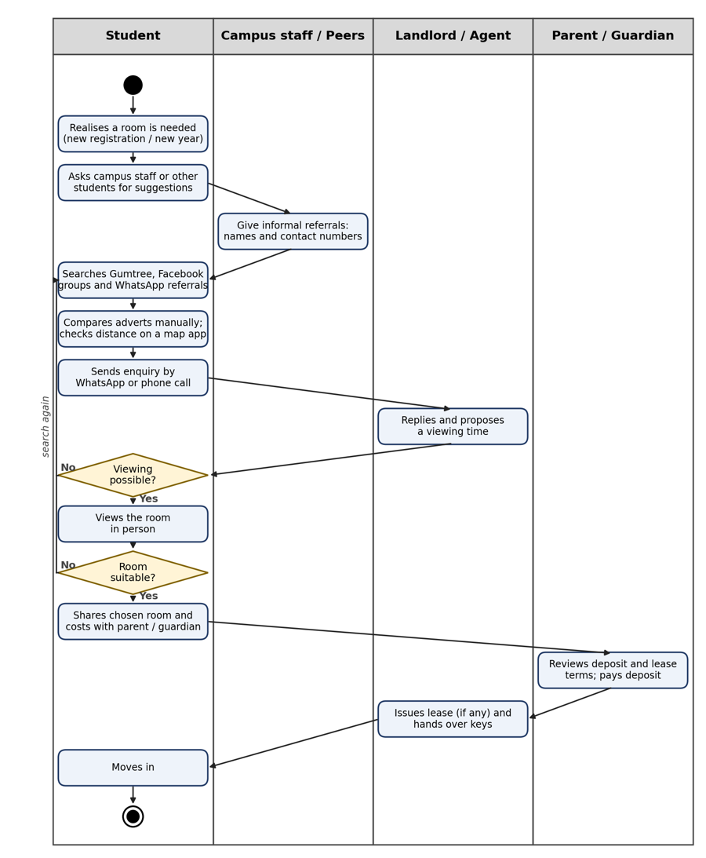
Figure 1: The As-is activity diagram of how a Richfield student currently finds off-campus accommodation

- Information handled in the current process
- Property details (rent, room type, amenities): are typed freely into adverts, so the same detail is described differently, or left out, from one listing to the next.
- Distance to campus is rarely stated; students check it themselves in a separate map application.
- Inspection or verification status is not recorded anywhere; students are advised to verify landlords themselves before paying (SABC News, 2017; Majadibodu, 2026).
- Enquiries and viewing arrangements sit in personal WhatsApp chats and call logs, with no reference number, status or history.
- Total move-in cost (deposit, admin fee and rent) is usually only fully known once the student is close to committing.
As a result, nobody in the process (student, parent, landlord or campus) sees a complete, consistent picture of the options and their cost. The weaknesses this causes are analysed in Section 3.5.

- Data Analysis (Data Integrity and Constraints)
EMERGEX holds nine tables, each with keys, types and rules that keep its data accurate; the analysis also found six rules the prototype does not yet fully enforce (3.4.5).

- Classification of Data
Type | Tables | Maintained by | Characteristics
Reference data | campuses, room_types, amenities, listings, listing_amenities, faqs | Staff or administrator | Changes rarely; read on almost every page
Captured data | viewing_requests, viewing_request_rooms | Students, through the viewing-request form | Grows over time; holds personal information protected under POPIA
Session data | shortlists | The student's browser (FR5) | Temporary; stored server-side only once student logins exist (Could-have)

- The Types of Integrity Enforced
Integrity type | Meaning | How EMERGEX enforces it
Entity integrity | Every row is uniquely identifiable | A primary key on every table; composite keys on link tables
Referential integrity | A foreign key always points to an existing row | Foreign-key constraints; listings are deactivated, not deleted
Domain integrity | Every value has the right type and range | Data types, NOT NULL and server-side validation (FR7)
Business-rule integrity | Data obeys the rules of the process | Rules BR-01 to BR-14, checked in PHP before any write

- Constraints Per Table
Table | Primary key | Key data types and constraints
campuses | id VARCHAR(40) | name, city, province VARCHAR(120) NOT NULL; lat, lng DECIMAL(10,7) NOT NULL; confirmed TINYINT(1) default 0; beds INT UNSIGNED default 0
room_types | id VARCHAR(40) | label VARCHAR(120) NOT NULL
amenities | id VARCHAR(40) | short VARCHAR(80) and label VARCHAR(160) NOT NULL
listings | slug VARCHAR (120) | campus_id → campuses and room_type → room_types (ON UPDATE CASCADE); area at suburb level only; lat, lng NOT NULL; rent INT UNSIGNED in whole rand; verified default 0; is_active default 1 (soft delete); created_at and updated_at set by the server; indexed on campus, rent and active status
listing_amenities | (listing_slug, amenity_id) | Both foreign keys, ON DELETE CASCADE; composite key prevents duplicate links
faqs | id INT AUTO_INCREMENT | question VARCHAR(300) and answer TEXT NOT NULL; is_active default 1
viewing_requests | id INT AUTO_INCREMENT | reference VARCHAR(20) UNIQUE; full_name, email, phone, campus_id, preferred_date (DATE), move_in_month (CHAR(7), YYYY-MM) NOT NULL; guardian_email and notes (≤ 500 characters) optional; campus_id → campuses; status default "new"; created_at default current time; indexed on campus, status and date
viewing_request_rooms | (request_id, listing_slug) | Both foreign keys; deleting a request deletes its room rows
shortlists | id INT AUTO_INCREMENT | listing_slug → listings; UNIQUE (owner_key, listing_slug); used only once logins exist

- Business Rules
Rule | Description | Enforcement | Requirement
BR-01 | Only active listings appear in search results | is_active = 1 in every listing query | FR2
BR-02 | A listing's inspected status is shown exactly as stored, never assumed | Badge drawn from the verified field only | FR3, NFR5
BR-03 | Campuses whose location is unconfirmed are labelled as such | "Location to confirm" badge when confirmed = 0 | FR1, NFR5
BR-04 | Every listing belongs to exactly one campus and one room type | NOT NULL foreign keys | FR2, FR3
BR-05 | A student may shortlist at most four listings | Limit checked before adding; duplicates ignored | FR5
BR-06 | A viewing request must name at least one listing | Required; not yet enforced server-side (3.4.5) | FR6
BR-07 | Rooms in a request must be active and belong to the selected campus | Partly enforced: rooms must exist, but are not matched to the campus (3.4.5) | FR6, FR7
BR-08 | Phone must be a South African mobile number (0 or +27, then 6, 7 or 8, then 8 digits) | Server-side pattern check | FR7
BR-09 | Preferred viewing date cannot be in the past | Server-side date check | FR7
BR-10 | Each request gets a unique server-generated reference (RF-YYMMDD-XXXX) | Generated in PHP; UNIQUE constraint | FR6
BR-11 | A request and its rooms are saved together or not at all | One database transaction | FR6
BR-12 | Only data needed to arrange a viewing is collected | No ID numbers, banking or funding documents | NFR5, POPIA
BR-13 | Move-in cost = rent for the lease term (less 5% upfront or 2% termly, on rent only) + deposit (rent × chosen deposit months) + fixed R 950 admin fee, in whole rand | Server-side calculation with fixed system constants | FR8
BR-14 | A listing's location is shown at suburb level, never as a street address | area holds the suburb only | NFR5, POPIA

- Findings from the Data Analysis
- Model Documentation Gaps: The Phase 2 ERD omitted attributes and a table that the requirements depend on: listing coordinates (FR3, FR4); move_in_month, guardian_email and notes (FR6); and the faqs table (FR10). All of these already exist in the prototype's schema and are added to the refined model in Section 3.8. FR8 needs no new fields, because the deposit and admin fee are fixed system settings (BR-13).

- Integrity Rules not yet fully enforced: Comparing the business rules with the prototype found the following, carried into Phase 4 as design corrections:

No. | Finding | Risk | Recommended correction
1 | A viewing request can be saved with no rooms selected | Requests the campus cannot act on | Reject the form if no listing is selected (BR-06)
2 | Selected rooms are not checked against the selected campus | A request for one campus naming another campus's room | Server-side campus match (BR-07)
3 | move_in_month and campus are accepted without checking them against the allowed options | Invalid values stored, especially when no database constraint applies | Validate against the generated month list and the campus list
4 | status is free text with no database restriction | Inconsistent statuses once an admin view is added | Restrict to new, contacted, viewed, closed (ENUM or CHECK)
5 | Deleting a listing removes it from past viewing requests (ON DELETE CASCADE) | Loss of request history | Use soft delete only and change the rule to ON DELETE RESTRICT
6 | Full-name length is not checked against the 160-character column | Truncation or a database error | Add a server-side maximum length

- Weaknesses of the Current System
The current process has eight weaknesses, all traceable to one root cause: there is no single, campus-linked source of structured and verified accommodation information. Each weakness below is linked to the as-is step where it occurs (Table 3.3.2) and to the EMERGEX requirement that addresses it.

No. | Weakness | Root cause | Where it occurs (as-is step) | Evidence | EMERGEX response
W1 | Search is fragmented across many channels | No central platform for Richfield students | Steps 2–4 | Observation 3.2.2 | One site for every campus and listing (FR1, FR2)
W2 | No search by campus and no distance information | Adverts are not linked to a campus or a location | Step 4 | Observation 3.2.2; students rank distance highly (Edwards, 2019; Kobue, Oke and Aigbavboa, 2017) | Campus filter, walking and driving times, map (FR2, FR3, FR4)
W3 | No way to tell a genuine or inspected property from a fake one | Inspection status is never recorded | Steps 3–6 | Scam reports and police warnings (Johnson, 2025; Sowetan, 2025; SABC News, 2017; Majadibodu, 2026) | Inspected badge shown only from stored data (FR3, BR-02)
W4 | Property information is inconsistent and incomplete | Free-text adverts with no required fields | Steps 3–4 | Observation 3.2.2 | Structured rent, room type and amenities for every listing (FR3, BR-04)
W5 | Full move-in cost is known only late, and parents are involved last | No tool to estimate costs; guardians are outside the process | Step 7 | As-is diagram (Figure 1); Phase 2 identification of need | Move-in cost estimate and optional guardian email (FR8, FR6)
W6 | Enquiries are untracked, with no reference or status | Contact happens in personal chats | Step 5 | Observation 3.2.2 | Viewing request with a unique reference and status (FR6, BR-10)
W7 | Students are pressured to pay a deposit before viewing | Scarcity, and no viewing-first process | Steps 5–7 | Scam reports (Johnson, 2025; Sowetan, 2025; Majadibodu, 2026) | A free viewing request that takes no payment; payment stays out of scope
W8 | Personal details are shared over uncontrolled channels | No secure, validated form | Step 5 | POPIA requirements (Republic of South Africa, 2013) | Validated form protected against cross-site request forgery; minimal data (FR7, FR9, BR-12)

W3 and WW7 carry the highest risk, because together they expose students to losing a deposit on a property that does not exist. W5 is the weakness most specific to Richfield, because the parent or guardian who pays is the last person to see the costs.

- Analysis of the Proposed System (Functional Requirements)
EMERGEX replaces steps 2 to 5 of the current process with one website. A student picks a campus, compares structured listings with distance and inspection status, estimates the full move-in cost, and sends one tracked viewing request that can name a parent or guardian.

- Actors
Actor | Type | Interaction with EMERGEX
Student | Primary | Searches, views listings, shortlists, estimates costs and submits viewing requests
Parent or guardian | Secondary | Optional email recorded with the request so staff can include them when following up
Staff (administrator) | Supporting | Maintains campuses, listings, amenities and FAQs; follows up viewing requests. No admin screen yet: data is maintained through the database and seed script (Could-have)

The prototype stores the guardian email but sends no emails yet. The site's FAQ says guardians "receive the same confirmation"; under NFR5 (Honesty) that answer must be reworded until email sending is built.

- Functional Requirements in Detail
Priorities follow the Phase 2 MoSCoW analysis.
ID | Requirement | Input | Processing | Output | Priority
FR1 | Display every campus with city, province, confirmed status and bed count | None | Read all campuses in sort order | Campus cards; "Location to confirm" badge where unconfirmed | Must
FR2 | Search listings by campus, maximum rent, room type and amenities | Filter selections | Query active listings matching all filters (BR-01) | Matching listings, or an empty-state message | Must
FR3 | Show rent, room type, inspected status, amenities and walking and driving distance for each listing | Listing selected | Read listing, room type and amenities; calculate distance from listing to campus coordinates | Listing page with badges and travel times | Must
FR4 | Plot listings and their campus on an interactive map | Campus or search result | Pass coordinates to the map library (Leaflet with OpenStreetMap) | Map with campus and listing pins | Must
FR5 | Shortlist up to four listings, kept across page reloads | Add or remove action | Check the four-item limit; store in the browser | Shortlist drawer; listings carried into the viewing request | Should
FR6 | Accept a viewing request with contact details, preferred date, move-in month and selected listings | Form fields | Validate (FR7), generate reference, save request and rooms in one transaction (BR-10, BR-11) | Confirmation showing the reference | Must
FR7 | Validate all viewing-request input server-side, including South African mobile format | Submitted form | Check each field against BR-06 to BR-09 | Field-level error messages, inputs kept | Must
FR8 | Estimate total move-in cost for a chosen lease length and payment plan | Rent, lease months, deposit months, plan | Apply BR-13 | Amount due now, instalment and total, in rand | Should
FR9 | Protect the viewing-request form against cross-site request forgery | Hidden session token | Compare the submitted token with the session token | Request rejected if the tokens differ | Must
FR10 | Keep showing campus, listing and FAQ content with no database connected | None | Fall back to built-in sample data | Same pages, with a sample-data notice | Must

- Use Cases
The use-case diagram (Figure 2) shows six use cases: UC1 Search listings, UC2 View listing details, UC3 Manage shortlist, UC4 Estimate move-in cost, UC5 Submit viewing request and UC6 Maintain reference data. UC5 is the main capture point of the system and is described in full below.
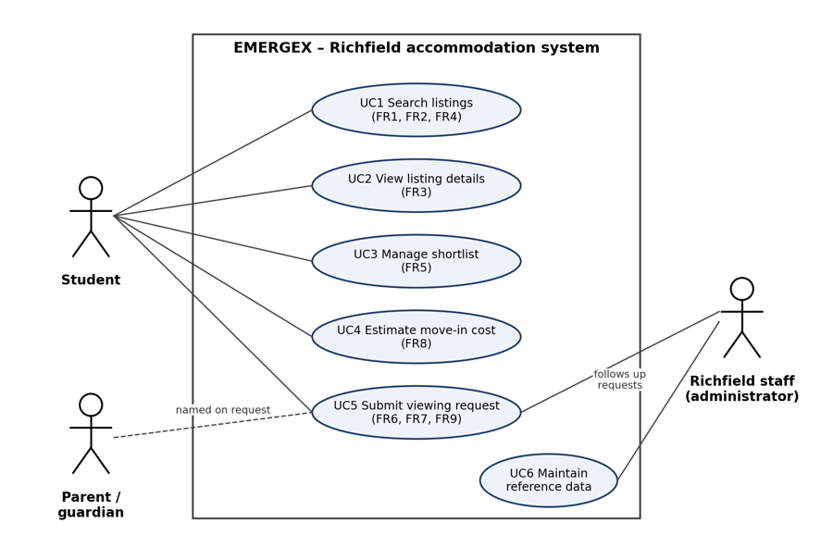
Figure 2: The Use-case diagram for the proposed EMERGEX system.

Field | UC5 Submit viewing request
Actor | Student (primary); parent or guardian (named on the request)
Requirements | FR6, FR7, FR9
Pre-condition | The student has found at least one listing from search, a listing page and etc.
Main flow | 1. Student opens the viewing-request form; listings from the shortlist or listing page are pre-selected.  2. Student enters full name, email, mobile number, optional guardian email, campus, preferred date, move-in month and optional notes, and confirms the selected rooms.  3. Student submits.  4. System checks the form token (FR9).  5. System validates every field (FR7).  6. System generates a unique reference (BR-10).  7. System saves the request and its rooms in one transaction (BR-11).  8. System shows a confirmation with the reference.
Alternative: invalid input | At step 5, the form is shown again with a message beside each invalid field, and the student's entries are kept
Alternative: expired session | At step 4, the request is rejected with "Your session expired. Please try again."
Alternative: database unavailable | At step 7, the system still validates and shows a reference, but clearly states the request was not saved (FR10)
Post-condition | One viewing request with status "new" and at least one linked room exists in the database

- Non-Functional Requirements
Each Phase 2 quality requirement now has a measurable acceptance criterion, and the analysis adds two requirements (NFR7, NFR8) that came out of the data analysis in 3.4. The last column records what the team's prototype test runs reported.
ID | Category | Requirement | Measurable criterion | How verified | Prototype status
NFR1 | Performance | Pages render server-side with no client build step, on ordinary shared hosting | Runs with only PHP 8.0 or newer; no package install or build step; every page returns HTTP 200 | Fresh install on a clean machine; route checks | Met: all routes return 200
NFR2 | Security | Every database query uses a parameterised statement; input is never joined into SQL | 0 queries built by string concatenation; injection attempts on every URL parameter leave the tables intact | Code review of the single query file; injection tests | Met
NFR3 | Portability | Runs unmodified on MySQL/MariaDB or SQLite through PDO | Same code passes the same checks on both drivers; only the configuration file changes | Run the acceptance checks on each driver | Met: both schemas provided
NFR4 | Accessibility | WCAG 2.2 AA colour contrast; every control keyboard-operable | Text contrast at least 4.5:1; every form, filter and drawer usable with keyboard only | Contrast checker; keyboard-only walkthrough | To be verified in Phase 5
NFR5 | Honesty | Never present sample data as real, or claim NSFAS eligibility or an affiliation not held | Sample-data notice and "not affiliated" footer on every page; 0 NSFAS claims | Page-by-page content review | Partly met: FAQ wording on guardian emails to correct (3.6.1)
NFR6 | Compatibility | No horizontal overflow from 360 px to 1920 px wide | 0 px horizontal scroll at 360, 390, 414, 768, 1024, 1280 and 1920 px | Browser test at each width | Met
NFR7 | Privacy (new) | Personal data is limited to what a viewing needs and protected under POPIA | Only the fields in BR-12 collected; credentials and data dumps never committed to the repository; a retention period agreed before go-live | Schema review; repository check | Partly met: retention period still to agree
NFR8 | Security (new) | Every value shown on a page is escaped, and errors are logged rather than shown | A script tag typed into any field is displayed as text; a database failure shows a friendly message, never a stack trace | Test with script input; test with the database stopped | Met

- Data Modelling for the Proposed System
The refined model completes the nine tables named in Phase 2 (its diagram drew eight) by adding the faqs table and the attributes the requirements need (3.4.5a); the context and Level 1 data-flow diagrams show how data moves between students, staff and these tables.

- Changes from the Phase 2 data model
Table | Change | Reason
listings | Added lat, lng, blurb, image_url, created_at, updated_at | Map and distance (FR3, FR4); listing page content; audit of changes
viewing_requests | Added guardian_email, move_in_month, notes | FR6 and the guardian visibility need (W5)
faqs | Added as the ninth table | FR10 FAQ content
campuses, room_types, amenities | Added sort_order | Fixed display order on every page
shortlists | Added created_at | Ordering saved rooms once logins exist

- Refined entity-relationship diagram
Figure 3 shows the refined ERD. A campus has many listings and many viewing requests; a listing has one room type and many amenities through listing_amenities; a viewing request names one or more listings through viewing_request_rooms. faqs stands alone.
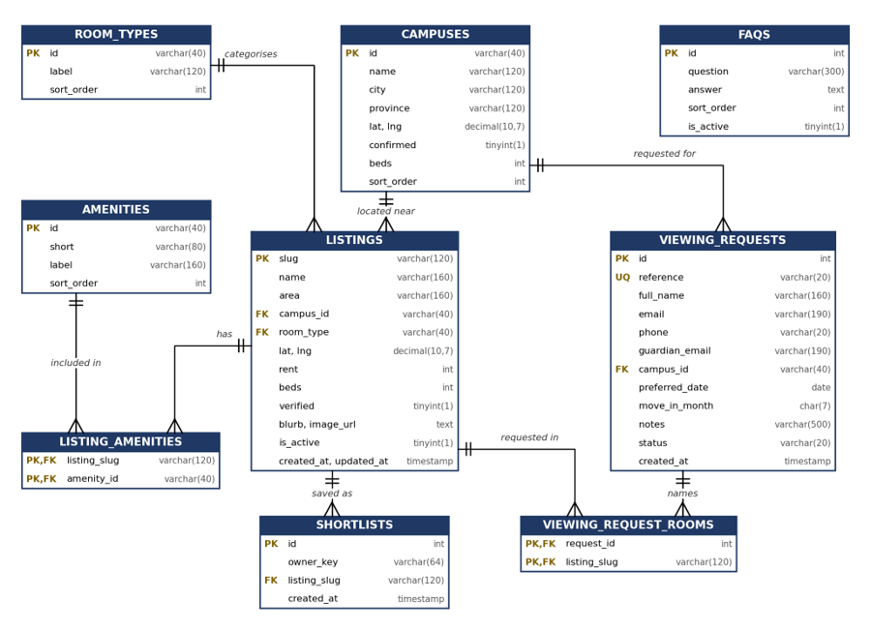
Figure 3: The Refined entity-relationship diagram (crow's foot notation)

- Data dictionary (captured data)
Reference tables are defined in 3.4.3. The table that holds personal information is defined in full here.
Field | Type | Null | Key | Description and rule
id | INT UNSIGNED, auto-increment | No | PK | Internal identifier
reference | VARCHAR(20) | No | UNIQUE | RF-YYMMDD-XXXX, shown to the student (BR-10)
full_name | VARCHAR(160) | No |  | At least 2 characters
email | VARCHAR(190) | No |  | Valid email address
phone | VARCHAR(20) | No |  | South African mobile number (BR-08)
guardian_email | VARCHAR(190) | Yes |  | Valid email address when given
campus_id | VARCHAR(40) | No | FK → campuses | Campus the student attends
preferred_date | DATE | No |  | Not in the past (BR-09)
move_in_month | CHAR(7) | No |  | YYYY-MM, one of the next 12 months
notes | VARCHAR(500) | Yes |  | Optional, at most 500 characters
status | VARCHAR(20) | No |  | new, contacted, viewed or closed; default new
created_at | TIMESTAMP | No |  | Set by the server at insert

viewing_request_rooms links each request to its listings with a composite primary key (request_id, listing_slug).

- Data-flow diagrams
The context diagram (Figure 4) shows EMERGEX as one process exchanging data with two external entities: the student and Richfield staff. The parent or guardian appears only as data (the optional guardian email), because the system does not yet send them anything. The Level 1 diagram (Figure 5) breaks the process into six sub-processes and four data stores; the shortlist is kept in the student's browser, so it has no data store.
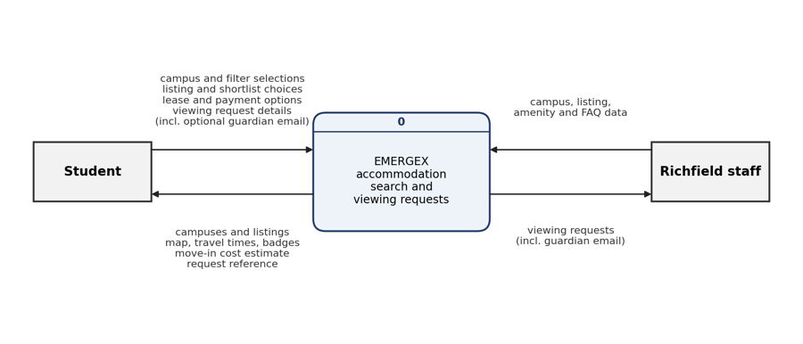
Figure 4: The Context-level data-flow diagram

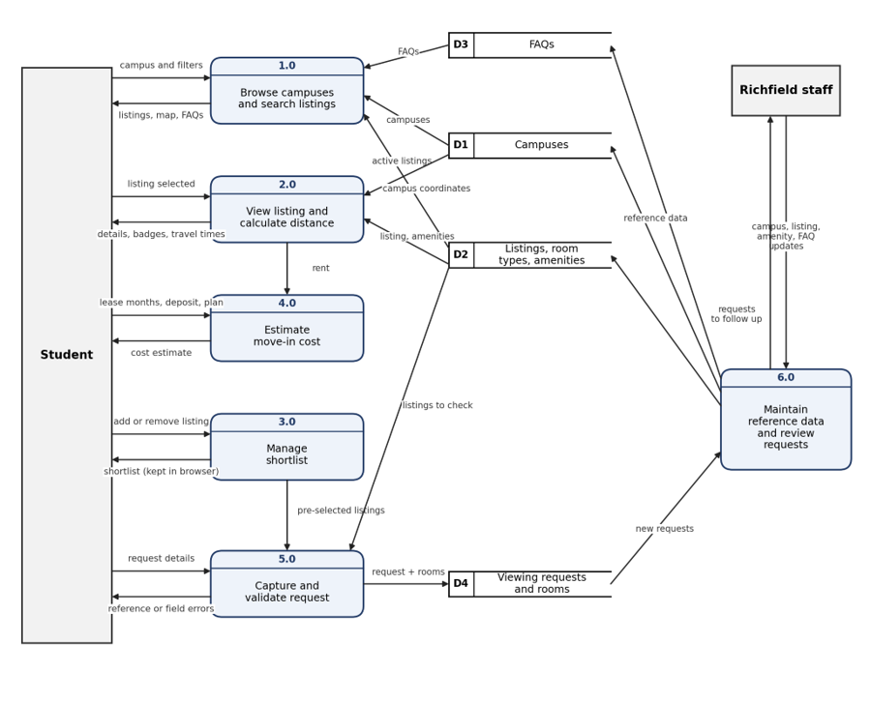
Figure 5: The Level 1 data-flow diagram

References
Edwards, S. (2019) Student preferences for accommodation at a Cape Town university: an application of the stated preference approach. Master's thesis. Cape Peninsula University of Technology. Available at: https://etd.cput.ac.za/handle/20.500.11838/3003 (Accessed: 6 October 2026).
Gumtree South Africa (n.d.) Student accommodation, Berea/Musgrave, Durban. Available at: https://www.gumtree.co.za/a-flat-share-house-share/berea-musgrave/student-accomodation/10013531794741012979699809 (Accessed: 6 October 2026).
Johnson, B. (2025) Addressing the student accommodation crisis in South Africa: safety, security, and solutions. Available at: https://sundayindependent.co.za/personal-finance/financial-planning/2025-02-16-addressing-the-student-accommodation-crisis-in-south-africa-safety-security-and-solutions (Accessed: 6 October 2026).
Kobue, T., Oke, A. and Aigbavboa, C. (2017). Understanding the Determinants of Students’ Choice of Occupancy for Creative Construction. Procedia Engineering, 196, pp.423–428. doi: 10.1016/j.proeng.2017.07.219.
Majadibodu, S. (2026) Students warned to be alert over accommodation scams, Pretoria News, 2 January. Available at: https://pretorianews.co.za/news/education/universities/2026-01-02-students-warned-to-be-alert-over-accommodation-scams/ (Accessed: 6 October 2026).
Richfield (n.d) Our campuses. Available at: https://www.richfield.ac.za/campuses (Accessed: 6 October 2026).
Richfield (n.d) Pretoria campus. Available at: https://www.richfield.ac.za/campus/pretoria (Accessed: 6 October 2026).
SABC News (2017) Police warn students of bogus accommodation advertisements. Available at: https://www.sabcnews.com/sabcnews/police-warn-students-bogus-accommodation-advertisements/ (Accessed: 6 October 2026).
South African Government (2013). Protection of Personal Information Act 4 of 2013 | South African Government. [online] www.gov.za. Available at: https://www.gov.za/documents/protection-personal-information-act (Accessed: 6 October 2026).
Sowetan (2025) Students warned about accommodation scams, Sowetan, 20 January. Available at: https://www.sowetan.co.za/news/2025-01-20-students-warned-about-accommodation-scams/ (Accessed: 6 October 2026).

